So What about That Da Vinci Code?
The Rev. Dr. Charles W. Allen
Indianapolis Lutheran Episcopal Campus Ministry

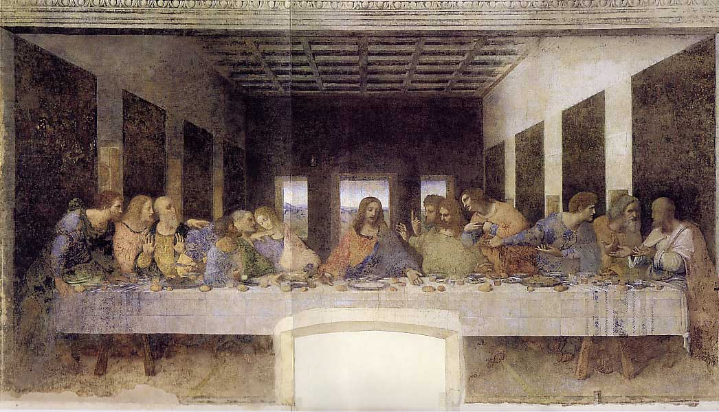

(Note to the reader: I’ve had so many inquiries about my take on The Da Vinci Code that I’ve decided to post an online response. I’m not that well-trained as an historian or biblical scholar, and the more “liberal” brand of Christian faith I represent is discounted by quite a few other Christians, so I welcome comments and criticisms, regardless of your viewpoint. If I think it’s needed, I may revise this in light of what I hear. E-mail me, if you want, at charlesallen5@yahoo.com.)

The Da Vinci Code (New York: Doubleday, 2003) is a story of intrigue about the secret existence of direct descendents from Jesus and Mary Magdalene. It’s supposed to be a secret that the Roman Catholic Church has tried to stamp out for centuries. It’s a fun story, and its success suggests that it’s possible to write a popular thriller based on what really happened in the early Christian movement.
Unfortunately, this is not that book. It’s not based on what really happened, as best anyone with any credentials can tell. As history or even history-based fiction, if you’ll forgive the expression, it just plain sucks. And that’s too bad. It might not be great literature, but it would really be a great service to faith and reason if somebody ever wrote as lively a novel—one accurate enough to help us face up to the way concerns for power, influence and liberation intersect in any human quest for truth. It could show us so much about ourselves—our dreams, our fleeting breakthroughs, our constant frustrations, and most of all, our need to accept ourselves as the fallible, anxious, too-self-concerned creatures that we are. That may be what Dan Brown was trying to do with this book, and if that’s so, I thank him for the effort. I just wish he could have done a more convincing job.
I’m writing this wearing several hats—campus minister, Episcopal priest and theology professor. I’m not an historian, so I’m not claiming that much expertise here. Still, I have an interest in weighing in. I represent a tradition that at least claims to esteem unfettered questions and criticisms just as much as it tries to live out of the truths it still finds in its sacred writings and respected traditions. We can stand and repeat the Nicene Creed together and still question how it got established and whether it really says that well what we might want to say today. (Of course we wouldn’t repeat it at all if we didn’t agree with it at least in spirit.) We have the same mixed attitude about the Scripture readings we hear in every service. We don’t think honest worship is possible without listening to all these voices at once. Do we really practice all that? Well, only sometimes, but that’s precisely why honest questioning is so important.
All of that is to say that there’s no need to pretend that, from about 100 CE onward, the development of the early Christian movement wasn’t deeply shaped by leaders (mostly male) who wanted control too much to be open to many differences. That’s hardly surprising in their context. What’s amazing is that a more liberating vision of radical hospitality kept reasserting itself. Just look at what later movements have made of Galatians 3:28: “There is no longer Jew or Greek, there is no longer slave or free, there is no longer male and female …” True, St. Paul seems to have been soft on the slavery issue and reluctant to give women much of a voice, but in my tradition we don’t have to pretend that he was always consistent. We can take him at his better, more liberating moments and turn him against his more controlling side.
We can be just as critical of the way early doctrines were defended and the way certain books got accepted as Scripture while others weren’t. People of the time often failed to live by their own deepest insights, and we can document that over and over. What we can’t afford to do is get fairly established facts dreadfully wrong or resort to conspiracy theories that make the John Birch Society look downright restrained. And that brings us back to The Da Vinci Code. I’m afraid it errs in both respects.
Here’s where Brown gets some basic, well attested facts dreadfully wrong about the early Christian movement (most of this is conveniently summarized in Chapter 55). If this starts to sound too fussy, feel free to skip ahead.
*Before 325, most of Jesus’ followers viewed him as no more than “a mortal prophet.” (Fact: From some of the very earliest sources we have, Jesus was always presented as mysteriously more than another prophet. He was considered by some to be divine, or at least worthy of worship, from before the end of the first century.)
*To help unify the Empire, the Roman Emperor Constantine called the Council of Nicaea in 325 to settle a conflict between Christians and pagans. (Fact: He called the council to settle a conflict between Christians and Christians, not Christians and pagans, though he did hope this would help unify the Empire.)
*Constantine was almost single-handedly responsible for getting Jesus declared to be God. (Fact: By this time all sides thought Jesus was divine in some way or other—they just couldn’t decide how much or in what way.)
*Constantine determined which books would go into the Bible as we know it today. (Fact: The question of which books belong in the Bible wasn’t addressed by any councils until over 50 years after Constantine’s death and was never settled by a universal council like Nicaea. There were certainly egos and power issues involved all the way along, and Constantine did pay for the production of 50 “Bibles,” but he did not decide what they would contain. That does cause me to wonder how much “marketing” influenced the final outcome.)
*Constantine established Sunday as the official day of worship. (Fact: Sunday as the principal day of worship was mentioned in the first and second centuries, because it was held to be the day of Jesus’ resurrection.)
*Constantine made the Roman Catholic Church the sole dispenser of salvation. (Fact: There was no “Roman Catholic Church” at the time. Rome was one of several centers of influence and was never recognized by the Eastern Church as any more than that.)
*Constantine made sure to omit from today’s Bible any gospels that spoke of Jesus’ human traits. (Fact: All the Gospels of today’s Bible speak of Jesus’ human traits. And the four we have seem to have been the most accepted from the 2nd century onward. The omitted gospels, on the other hand, often denied his humanity and sometimes made him more of a wonder-worker than the four that got included.)
*Some of the omitted “humanizing” gospels were rediscovered among the Dead Sea Scrolls and the Nag Hammadi Library. (Fact: There are no gospels, and not even any references to Jesus, in the Dead Sea Scrolls. The gospels in the Nag Hammadi collection are not more “humanizing” about Jesus. They were gospels prized by Gnostics, many of whom specifically denied Jesus’ full humanity. Look, for example, at the Gospel of Thomas, 77:1-3: “Jesus said, “I am the light that is over all things. I am all: from me all came forth, and to me all attained. Split a piece of wood; I am there. Lift up the stone, and you will find me there.” How human is that Jesus?)
Now of course in historical reconstructions one person’s fact can be another person’s opinion. But what I’m calling facts are at least opinions shared by a very wide variety of scholars, and many of them have no interest in making Christians look good. There’s no disputing that Constantine had a major impact on how the Church developed. And to me, at least, much of that influence seems unhealthy. And it’s also true that early Christians could come across as pretty mean-spirited and intolerant once they gained any influence. The undisputed history of the Church is scandalous enough, all by itself. Brown didn’t need to invent anything to make this period look like a soap opera. (Try reading Richard Rubenstein’s When Jesus Became God [New York: Harcourt, Inc., 1999]. It’s racy but, as far as I can tell, about as accurately told as a non-technical book could be.) So that’s why I’m really puzzled that he seems to have preferred invention to what scholars of nearly all stripes would consider the real thing.
I’m actually less puzzled, and less taken aback, by Brown’s conspiracy theory about Jesus’ and Mary Magdalene’s marriage, and the secret dynasty they supposedly started. Some of the omitted gospels do suggest that they were pretty chummy, even if most scholars discount their accuracy. And the stories about their offspring do at least claim to be based on “secret” documents and the work of people who pass for scholars in some circles. (Can you tell that those circles aren’t the ones I run in?) That’s at least consistent, even if none of these claims are credited by any widely recognized scholars. And besides, conspiracy theories always have ways of discrediting recognized scholars.
Let me just point out that, if any of this stuff about Jesus’ secret bloodline were true (and that’s about as likely as George W. Bush turning out to be a secret Marxist intellectual), I’m not sure it would have prevented the early Christian movement from going ahead worshipping Jesus and eventually declaring him to be the human embodiment of “true God from true God.” His full humanity, after all, never dropped completely out of the official picture. The divinity the Church has traditionally claimed for Jesus (whatever we make of that) doesn’t depend on whether or not he was a virgin. And if I did meet people who somehow convinced me they were his direct descendents, I’m afraid my reaction as a practicing Christian would be, “Well, that’s interesting, but so what? I thought he taught us not to be impressed with people’s lineage.” (Okay, maybe I’d be more impressed than that, but only because I can be impressed by celebrities.)
Now again, this is only a novel, and it’s fun and sometimes instructive to imagine an alternative past. What concerns me is that I keep hearing people talk as if this were a revelation of what really happened back then. And of course it is a popular version of what a handful of well-read Ph.D.s believe really happened. But you can find a handful of well-read Ph.D.s who think they’ve been to Mars and another handful who think Noah’s flood really happened the way it’s told and another handful (or maybe the same handful) who think every theory of evolution is another secular humanist conspiracy. So what might account for this handful’s popularity right now?
I think a great deal of its popularity depends on our growing awareness that our official versions of the past (and the present) have been influenced way too much by the assumptions of certain types of males. I refer to this as a “growing awareness” because I think it’s true, and easily supported. The voices of women, along with other voices from other cultures, have largely been actively excluded or else left out of reckoning in today’s and yesterday’s most dominant approaches to naming and living in the world. And while it’s dangerous to stereotype “women’s experience” (or men’s or the experience of others), I think the ways we tend to approach the world have been impoverished as a result of that kind of exclusion.
And in Christian churches we suffer from the ways our forebears silenced women and people who didn’t agree with them. We’ve impoverished our own worship by imagining God almost exclusively as a giant male and ignoring other images of God (e.g., Lady Wisdom) in our own Scriptures and traditions. We need to do something to address our lop-sided heritages, both inside and outside the churches.
And lots of people are doing something. They’re recovering or noticing insights and contributions that never were completely drowned out, just ignored (e.g., Macrina, Hildegard of Bingen, Julian of Norwich, Theresa of Avila). They’re learning to read well-established texts and traditions with new sensitivities. (Didn’t St. Paul end his letter to the Romans with a greeting to a woman Apostle? Hmm. Who were the first proclaimers of Jesus’ resurrection?). (See below for some sources.) They’re inviting us to start approaching the world and the people we meet in it with new eyes that welcome differences. I’m grateful to be living in a time when all this is happening. Call me a naïve, politically correct, guilt-ridden white male, if you want, but I’m going to keep wagering that these new movements toward more inclusive visions of the present and the past are the ones most worth supporting.
But the point is, I think we already have plenty of credible ways of looking at our pasts, ways that lots of careful inquirers of various cultures and genders are providing us, without resorting to reconstructions of the past that only the most sinister conspiracy theories can justify. Let’s move on.

A Few Sources on the “Divine Feminine” and Women’s Leadership

Isaiah 66:12-13: For thus says the LORD: I will extend prosperity to her like a river, and the wealth of the nations like an overflowing stream; and you shall nurse and be carried on her arm, and dandled on her knees. As a mother comforts her child, so I will comfort you; you shall be comforted in Jerusalem.

2 Esdras 1:28-30: “Thus says the Lord Almighty: Have I not entreated you as a father entreats his sons or a mother her daughters or a nurse her children, so that you should be my people and I should be your God, and that you should be my children and I should be your father? I gathered you as a hen gathers her chicks under her wings.

Wisdom of Solomon 7:22-27: Wisdom, the fashioner of all things, taught me. There is in her a spirit that is intelligent, holy, unique, manifold, subtle, mobile, clear, unpolluted,
distinct, invulnerable, loving the good, keen, irresistible, beneficent, humane, steadfast, sure, free from anxiety, all-powerful, overseeing all, and penetrating through all spirits
that are intelligent, pure, and altogether subtle. For wisdom is more mobile than any motion; because of her pureness she pervades and penetrates all things. For she is a breath of the power of God, and a pure emanation of the glory of the Almighty; therefore nothing defiled gains entrance into her. For she is a reflection of eternal light, a spotless mirror of the working of God, and an image of his goodness. Although she is but one, she can do all things, and while remaining in herself, she renews all things; in every generation she passes into holy souls and makes them friends of God, and prophets.

Matthew 23:37: Jerusalem, Jerusalem, the city that kills the prophets and stones those who are sent to it! How often have I desired to gather your children together as a hen gathers her brood under her wings, and you were not willing!

Romans 16:1-7: I commend to you our sister Phoebe, a deacon of the church at Cenchreae, so that you may welcome her in the Lord as is fitting for the saints, and help her in whatever she may require from you, for she has been a benefactor of many and of myself as well. Greet Prisca and Aquila, who work with me in Christ Jesus, and who risked their necks for my life, to whom not only I give thanks, but also all the churches of the Gentiles. Greet also the church in their house. Greet my beloved Epaenetus, who was the first convert in Asia for Christ. Greet Mary, who has worked very hard among you. Greet Andronicus and Junia, my relatives who were in prison with me; they are prominent among the apostles, and they were in Christ before I was.

Since Wisdom herself is our home, she also made herself for us into the way home … So it was not by locomotion through space that she is said to have come to us, but by appearing to mortals in mortal flesh. So she came to a place where she already was, because she was in the world, and the world was made through her … So why did she come, when she was already here, if not because it was God’s pleasure through the folly of preaching to save those who believe? How did she come, if not by the Word becoming flesh and dwelling amongst us? [Augustine, Teaching Christianity: De Doctrina Christiana, trans. by Edmund Hill, O. P. (Hyde Park, NY: New City Press, 1996), I.10.10-I.12-13 (pp. 110-111).]

