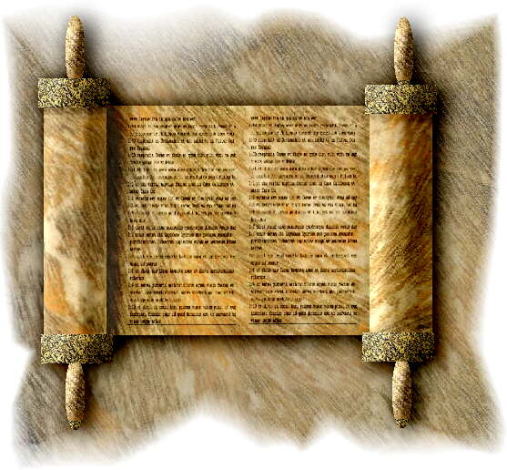
Let the Reader Understand
Principles of Biblical Interpretation for a Welcoming, Self-Critical Christian Community

1. The Holy Scriptures of the Old and New Testaments are “the Word of God” and “contain all things necessary to salvation.” They are called the Word of God by the household of faith, not because God dictated the biblical text, but because the Church believes that God inspired its human authors through the Holy Spirit and because by means of the inspired text, read within the sacramental communion of the Church, the Spirit of God continues the timely enlightenment and instruction of the faithful.

2. The Holy Scriptures are the primary constitutional text of the Church. They provide the basis and guiding principles for our common life with God, and they do so through narrative, law, prophecy, poetry, and other forms of expression. Indeed, the Scriptures are themselves an instrument of the Church’s shared communion with Jesus Christ, the living Word of God, who uses them to constitute the Church as a Body of many diverse members, participating together in his own word, wisdom, and life.

3. The Scriptures, as “God’s Word Written,” bear witness to, and their proper interpretation depends upon, the paschal mystery of God’s Word incarnate, crucified and risen. Although the Scriptures are a manifestly diverse collection of documents representing a variety of authors, times, aims, and forms, the Church received and collected them, and from the beginning has interpreted them for their witness to an underlying and unifying theme: the unfolding economy of salvation, as brought to fulfillment in Jesus Christ.

4. The Scriptures both document and narrate not only God’s saving acts but also the manifold human responses to them, revealing that God’s unchanging purpose to redeem is fulfilled, not by means of a coercive, deterministic system, but through a divine plan compassionately respectful of human freedom, adapted to changing historical circumstances, cultural situations, and individual experience and need. In reading the diverse texts of Holy Scripture, the Church seeks an ever-growing comprehension of this plan and of the precepts and practices whereby believers may respond more faithfully to it, walking in the way of Christ.

5. The New Testament itself interprets and applies the texts of the Old Testament as pointing to and revealing the Christ. Thus, the revelation of God in Christ is the key to the Church’s understanding of the Scriptures as a whole.

6. Individual texts must not, therefore, be isolated and made to mean something at odds with the tenor or trajectory of the divine plan underlying the whole of Scripture.

7. It must be concluded that the words of a scriptural text or texts, however compelling, may not in every circumstance be received by the Church as authoritative. Even if the Church has no authority to abrogate “commandments which are called Moral” — unlike its jurisdiction in “ceremonies and rites” — the true moral significance of any commandment is not simply given but must be discerned.

8. Thus, for the Church’s judgment of the morality of actions and dispositions to be authoritative, it is insufficient simply to condemn those things that are condemned somewhere in Scripture, or to approve those things that are somewhere approved.

9. Faithful interpretation requires the Church to use the gifts of “memory, reason, and skill” to find the sense of the scriptural text and to locate it in its time and place. The Church must then seek the text’s present significance in light of the whole economy of salvation. Chief among the guiding principles by which the Church interprets the sacred texts is the congruence of its interpretation with Christ’s Summary of the Law and the New Commandment, and the creeds.

10. The Church’s interpretation of Scripture is itself part of the human response to the economy of salvation, an essential means whereby the Christian faithful understand God’s actions in their lives and experience and therein know God’s power and purpose to judge, redeem, liberate, and transform.

11. Yet precisely because the Church’s members are human, their reading of Scripture is contingent and fallible, even in matters of faith and morals. In reading its Scriptures, the historical Church remains always a wayfaring community using discernment, conversation, and argument to find its way.

12. Interpretative security rests not in an indefectible community or infallible magisterium but in the tested deposit of the baptismal faith and, above all, in the covenant God who is faithful to a people who err.

13. To affirm the “sufficiency of the Holy Scriptures for salvation” is to enlarge the sphere of human liberty by acknowledging limits upon what may be required in matters of faith and morals. Taken in this way, the Scriptures do not lose their authority but on the contrary fulfill their ultimate intent, which is to bring all people to the blessed liberty of the children of God, whose service is perfect freedom.

******

Grace Unlimited
Celebrating God’s love on God’s terms,
unlimited by ours
A Ministry of Indianapolis
Lutheran-Episcopal Campus Ministry
The Rev. Dr. Charles W. Allen, Chaplain
317-319-7736 (H: 317-924-3971) charlesallen5@yahoo.com
www.indylutheran.org/campusministry/
www.therevdrcharleswallen.com

Developed at the request of the Episcopal Bishop of New York in response to actions of the Lambeth Conference1998. Members of the Hermeneutics Study Group: Dr. Deirdre Good, Th. D., The Rev. Br. Tobias Stanislas Haller, BSG, The Rev. Gaylord Hitchcock, Jr., The Rev. Gerald Keucher, The Rev. J. Christopher King, D.Phil., The Rev. Dr. John Koenig, The Rev. Canon Richard Norris, D.Phil., The Rev. Lloyd Prator, The Rev. Emmanuel Sserwadda. Copyright © 2002 The Diocese of New York of the Episcopal Church. This publication may be reproduced for study and noncommercial purposes in whole or in part provided this copyright notice is included.
The Oath of Conformity and the VI Article of Religion, the Book of Common Prayer (American), pp. 538, 868.
An Outline of the Faith, the Book of Common Prayer (American), p. 853, the Holy Scriptures.
The XIX Article of Religion, the Book of Common Prayer (American), p. 871.
The XX Article of Religion, the Book of Common Prayer (American), p. 871. “You search the Scriptures because you think that in them you have eternal life; and it is they that bear witness to me.” John 5:39.
See Acts 11:1-18, 13:46-48.
Matthew 26:54; Luke 4:21, 24:27; Acts 8:35, 18:28. “The Old Testament is not contrary to the New: for both in the Old and New Testament everlasting life is offered to Mankind by Christ, who is the only Mediator between God and Man, being both God and Man.” The VII Article of Religion, the Book of Common Prayer (American), p. 869.
The Church has no right “so [to] expound one place of Scripture, that it be repugnant to another.” The XX Article of Religion, the Book of Common Prayer (American), p. 871.
Laws of Ecclesiastical Polity I.XV.3, Richard Hooker.
The VII Article of Religion, the Book of Common Prayer (American), p. 869.
The Book of Common Prayer (American), p. 370.
“Unto the word of God, being in respect of that end for which God ordained it perfect, exact, and absolute in itself, we do not add reason as a supplement of any maim or defect therein, but as a necessary instrument, without which we could not reap by the Scripture’s perfection that fruit and benefit which it yieldeth.” Hooker, Laws III.8.10.
Matthew 22:37-40; John 13:34.
See Romans 8:15, 21.
The XIX Article of Religion, the Book of Common Prayer (American), p. 871.
See Luke 24:41-49.
The VI Article of Religion, the Book of Common Prayer (American), p. 868.

